**HANDS ON EXPERIMENT**

**PIR SENSOR**

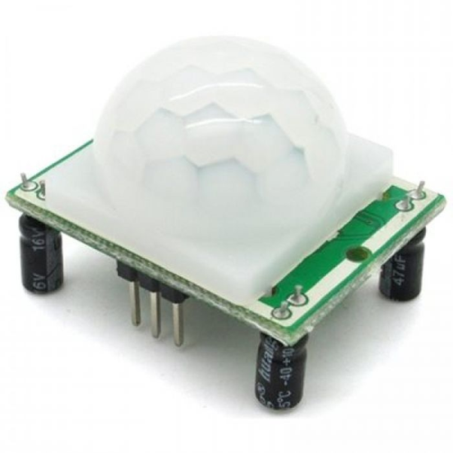

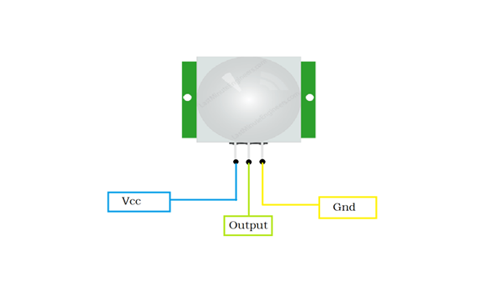

**A passive infrared sensor** (PIR ) also called as motion sensor is an electronic device which senses motion using a pair of pyroelectric sensors to detect heat energy in the surrounding environment. These two sensors sit beside each other, and when the signal differential between the two sensors changes ( suppose if a person enters the room), the sensor will engage. It basically catches movement. It has three terminals namely Gnd, Vcc and signal pin with 3V regulator, time delay controller, sensitivity controller and BIS001.

**CODE**

const int led = 9; // Led positive terminal to the digital pin 9.

const int sensor = 5; // signal pin of sensor to digital pin 5.

const int state = LOW;

const int val = 0;

void setup() { // Void setup is ran only once after each powerup or reset of the Arduino board.

pinMode(led, OUTPUT); // Led is determined as an output here.

pinMode(sensor, INPUT); // PIR motion sensor is determined is an input here.

Serial.begin(9600);

}

void loop(){ // Void loop is ran over and over and consists of the main program.

val = digitalRead(sensor);

if (val == HIGH) {

digitalWrite(led, HIGH);

delay(500); // Delay of led is 500

if (state == LOW) {

Serial.println(" Motion detected ");

state = HIGH;

}

}

else {

digitalWrite(led, LOW);

delay(500);

if (state == HIGH){

Serial.println("The action/ motion has stopped");

state = LOW;

}

}

}

